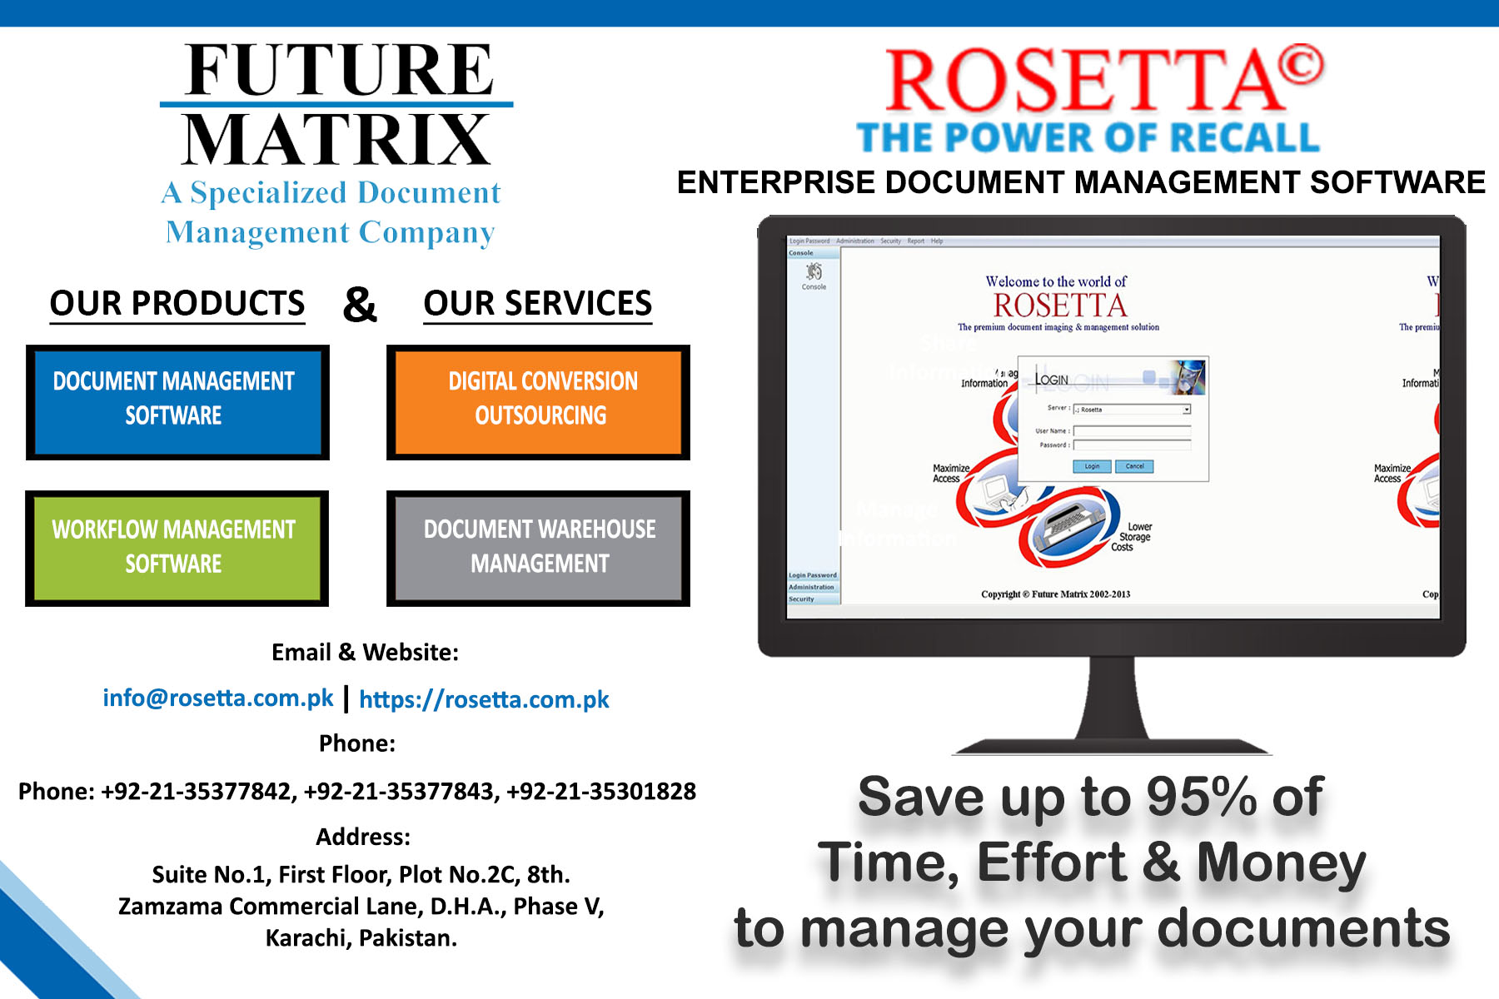
Dear Mr. «Fist_Name» «Last_Name»,
Let me introduce the Importance of Document Management Software for your Organization’s Productivity,
In today's fast-paced digital world, effective document management is vital for organizations striving to maximize productivity and streamline their operations. From reducing cluttered office spaces to automating workflows, document management systems have become essential tools for efficient business processes. In this email, we will explore the significance of document management for organizational productivity and highlight how Future Matrix, with its comprehensive suite of solutions, including ROSETTA Document Management Software, ROSETTA Workflow Automation Solution, Document Scanning and Digitization Services, and Document Warehouse Management Services, can be your one-stop-shop for all your document management needs.
Enhancing Efficiency through ROSETTA Specialized Document Management Software: Imagine a world where you can effortlessly store, organize, retrieve, and share all your important documents with just a few clicks. ROSETTA Document Management Software makes this a reality. This cutting-edge software helps businesses maintain a centralized repository of documents, enabling seamless collaboration, improving document security, and optimizing documents management operations. By eliminating the cumbersome paper-based processes and enabling quick access to critical information, ROSETTA empowers organizations to work smarter and faster.
Streamlining Workflows with ROSETTA Workflow Automation Software Solution: Manual and repetitive tasks can drain valuable time and resources. ROSETTA Workflow automation solution simplify complex business processes by automating routine tasks, approvals, and notifications. ROSETTA Workflow Automation Software integrates seamlessly with ROSETTA Document Management Software, eliminating bottlenecks and reducing human errors. By streamlining workflows, organizations can achieve greater efficiency, faster turnaround times, and improved employee satisfaction.
Effortless Transition: Document Scanning and Digitization: The era of overflowing file cabinets and endless stacks of paper documents is quickly becoming a thing of the past. Document scanning and digitization services offered by Future Matrix enable organizations to convert physical documents into digital formats. This process not only saves physical space but also enhances accessibility, searchability, and disaster recovery. Say goodbye to the time-consuming search for misplaced documents, as digitization brings all your critical information at your fingertips.
Seamless Storage and Access: Document Warehouse Management Services: Large-scale organizations often struggle with the management of physical documents due to limited space and time-consuming retrieval processes. Future Matrix's Document Warehouse Management Services provide a secure and cost-effective solution. By outsourcing document storage, indexing, and retrieval to professionals, organizations can focus on their core activities while ensuring the safety and compliance of their valuable records. With state-of-the-art facilities and robust security measures, Future Matrix takes the burden off your shoulders, ensuring seamless storage and access to your physical documents when needed.
Conclusion: In a competitive business landscape, every minute counts. Document management plays a pivotal role in enhancing organizational productivity by reducing paperwork, streamlining processes, and improving access to critical information. Future Matrix offers a comprehensive suite of solutions, including ROSETTA Document Management Software, ROSETTA Workflow Automation Software Solution, Document Scanning and Digitization Services, and Document Warehouse Management Services. By partnering with Future Matrix, organizations can optimize their document management practices and unlock new levels of efficiency, ultimately leading to increased productivity and success in the digital age.
Don't let outdated document management practices hold your organization back. Embrace the future with Future Matrix, your trusted one-stop-shop for all your document management needs.
To book a DEMO or POC, please reach out to us at the following details.
Email: info@rosetta.com.pk
Contact: +92-21-35377842 | +92-21-35377843 | +92 -21 35301828
Cloud Version of ROSETTA DMS - 14-Days Free Trial: https://bit.ly/demorosetta
Thanks & Best Regards,
Obaid Khan Manager Digital Marketing  Future Matrix  http:/rosetta.com.pk
 +9221-35377842 -3  +92 331 2258916  obaid@rosetta.com.pk
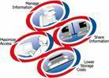 |  | DISCLAIMER:  "The information contained in this message(including any attachments) is confidential and may be protected by legal privilege. It is intended only for the person(s)named as addressee. The dissemination, distribution,copying or disclosure of this message, or its contents is strictly prohibited unless authorized by Future Matrix. If you have received this message in error, please return it to the sender at the above address".

